COMP5530 Deep Learning Project Report
Theodore Boswell^{#1}, Russell Jones^{#2}
#Computer Science Department, University of Massachusetts Lowell
¹theodore_boswell@student.uml.edu
²russell_jones@student.uml.edu

Abstract— This study explores the use of a convolutional neural network to detect building footprints in high-resolution satellite imagery. Using the SpaceNet-7 dataset, we convert polygon-based building annotations into raster masks and train a U-Net model to perform pixel-level classification. Each 1024×1024 scene is divided into 256×256 tiles, producing a manageable set of training samples without distorting spatial detail. The network is implemented directly from the original U-Net specification and trained with a combination of binary cross-entropy and intersection-over-union losses. We evaluate performance using accuracy and Dice score, showing that the model can reliably highlight built structures across a variety of suburban environments. This approach demonstrates that a straightforward segmentation pipeline can provide a useful first step toward automated tools for suburban analysis and city-planning support.

Keywords— Deep Learning, Convolutional Neural Network, Satellites, City Planning, Urban Development
- Introduction
suburban planners operate within an environment defined by rapid demographic change, limited land availability, and increasingly complex infrastructure demands. As cities expand and evolve, decision-makers must negotiate competing priorities: housing needs, transportation networks, environmental constraints, and social equity. The physical form of a city is shaped by countless interacting variables, and the data necessary to manage those variables—parcel boundaries, building footprints, land-use classifications, and informal structures—are often incomplete, inconsistent, or outdated. High-quality spatial information is essential for designing sustainable and resilient suburban systems, yet gathering this information at scale remains labor-intensive and costly. Satellite imagery has become an invaluable resource for monitoring suburban growth, but its utility depends on the ability to reliably extract meaningful features from vast visual datasets. Manual annotation of building footprints, especially in regions experiencing rapid or unregulated development, can lag months or years behind real conditions. This delay hampers efforts to plan infrastructure upgrades, estimate housing density, analyze patterns of informal settlement, or evaluate disaster-risk exposure. Automated methods promise to close this information gap, but they must be robust enough to handle the visual variability of the built environment: differences in architectural style, roof materials, vegetation cover, and imaging conditions such as shadows or seasonal changes.
- Motivations
Recent advances in deep learning offer new approaches to these challenges. Convolutional neural networks (CNNs), in particular, have demonstrated strong performance on tasks requiring recognition and delineation of complex shapes within noisy or heterogeneous visual data. For suburban analysis, CNN-based models can provide consistent, reproducible building detection at a scale unattainable through traditional mapping techniques. By transforming raw satellite imagery into structured representations of housing patterns, these systems can support a wide range of planning activities—from estimating infrastructure demand to identifying suburban expansion corridors. The model presented in this paper contributes to this growing body of work by focusing on the automated identification of houses from satellite imagery. Its goal is to reduce the persistent information bottleneck that constrains effective city planning. Through improved feature extraction and classification, the system is designed to deliver timely, accurate spatial data that can help planners respond to suburban dynamics with greater precision. This approach illustrates how modern computer vision methods can strengthen the empirical foundation on which planning decisions rely, opening pathways for more adaptive and informed suburban development strategies.
- Related Work
Research in satellite-image analysis has grown rapidly over the past decade, and many of its central ideas shape the approach taken in this work. Earlier studies on geo-object detection demonstrated that convolutional neural networks can successfully identify a wide range of structures and land-cover types in multispectral data, even when the imagery varies in resolution and acquisition source. One such line of work evaluated several CNN architectures across datasets from Landsat-8, PlanetScope, and the DSTL collection, showing that pixel-level segmentation is practical for applications in urban planning and environmental management [1]. Their findings reinforce a key premise underlying our study: CNN-based segmentation is not only feasible at satellite scales, but it also adapts well to different object classes when paired with appropriate ground-truth data. Additional support comes from research focused on urban environments in the Global South. A recent study applied deep learning to classify patterns of housing density and found that CNNs can extract meaningful spatial structure even in heterogeneous and informal settings [2]. That work also proposed a full training pipeline for high-level urban scene classification and validated its outputs against independent building-density estimates. Although their goal was not pixel-wise footprint extraction, the success of CNNs in capturing the fine-grained texture of dense settlements directly motivates our use of a U-Net model for identifying building shapes. Both efforts rely on the same broader insight: detailed urban morphology is encoded in the imagery, and deep networks are capable of retrieving it. There is also a growing recognition that satellite-based inference plays a crucial role in development and planning. Studies exploring rural infrastructure allocation and poverty-targeting strategies have shown that remote-sensing models provide data at a scale that traditional surveys cannot match [3]. These works highlight how automated extraction of built structures can feed into decisions about resource distribution, electrification, and long-term planning in regions where ground data are sparse. While our project focuses specifically on detecting buildings rather than estimating socioeconomic conditions, it fits naturally into this broader trajectory of using satellite imagery as a foundation for decision support in both urban and rural contexts. Together, these prior efforts help position our work within a maturing research area. They show that CNN-based segmentation is a well-established technique for extracting physical structures, that urban form is quantifiable from overhead imagery, and that such information has real value for planning and policy. This context supports our use of a U-Net architecture to produce building-footprint masks as a step toward scalable tools for analyzing urban development.
- Approach
The goal of this project is to identify building footprints in high-resolution satellite imagery using a convolutional neural network. We frame the task as a binary segmentation problem, where each pixel in an input image is classified as either building or non-building. Because the raw SpaceNet-7 dataset consists of large 1024×1024 satellite scenes, we subdivide each scene into smaller 256×256 tiles. This tiling step creates manageable training samples while preserving enough spatial context for the network to recognize the shape and texture patterns associated with built structures. SpaceNet-7 provides building footprint annotations as GeoJSON polygons rather than pixel masks. To produce training labels aligned with our tiles, we rasterize the polygon footprints onto the image grid and mark the corresponding pixels as positive. This process turns each tile into a paired example: a 256×256 RGB image and a corresponding 256×256 binary mask. From the 60 scenes in the training collection, we generate roughly 960 tiles sampled uniformly across the imagery.

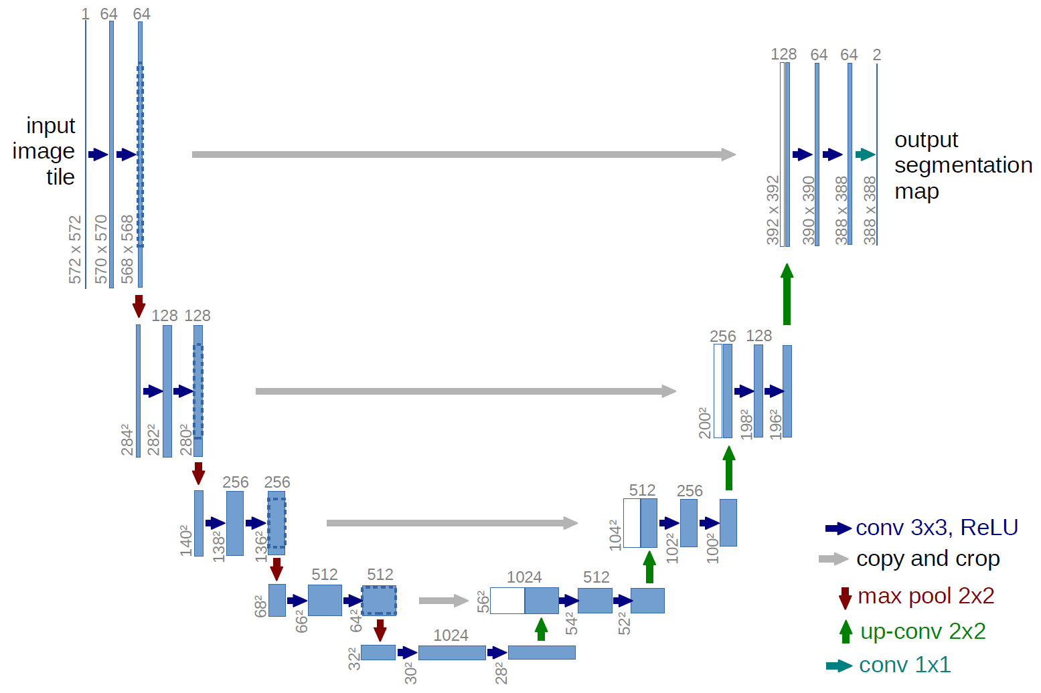
Figure 1: Classic U-Net Architecture
Our model follows the U-Net architecture, implemented from scratch rather than using a library preset. The structure mirrors the original design: an encoder that compresses spatial information into higher-level features, and a decoder that gradually rebuilds spatial detail while drawing on skip connections from earlier layers. This architecture has become a standard choice for segmentation tasks because it balances global context with fine-grained localization, which is crucial when distinguishing narrow rooftops or irregularly shaped buildings from their surroundings. Training uses binary cross-entropy combined with dice loss to encourage better alignment between predicted masks and ground-truth footprints. The network is optimized to penalize both false positives and false negatives, since either mistake can distort downstream analyses such as estimating building density or assessing land-use patterns. We evaluate the model using pixel-wise accuracy and Intersect over Union (IoU), which provides a clearer sense of how well the predicted shapes overlap the actual footprints.
This approach produces a system capable of detecting buildings across the diverse range of scenes in SpaceNet-7, regardless of timestamp. By focusing on per-image segmentation rather than temporal prediction, the model remains simple while still supporting applications in suburban-change analysis, infrastructure mapping, and general city-planning workflows.
- Experimental Results and Discussion
After having our model train on the previously mentioned data with a 90/10 split to withhold data on our model for evaluation and an 80/20 split for training and validation we used the previously mentioned metrics to optimize the model. At each epoch we recorded the models accuracy and loss over time to determine the best suited learning rate.

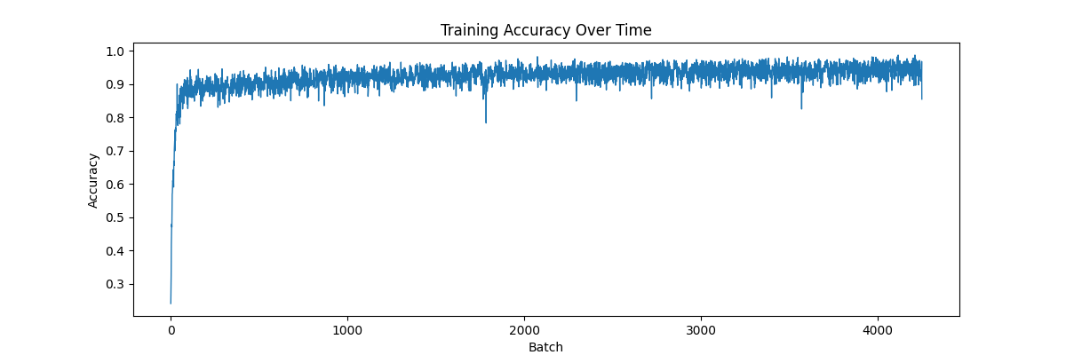
Figure 2: Accuracy over Epochs
From Figure 2 we determine that the model's accuracy explodes quickly within the first couple of epochs. The accuracy remains volatile throughout the training but we notice the recorded accuracy slowly grows and smooths. As the model starts to slow down, our early stopping criteria will prevent overfitting, or the model will continue to improve and converge.

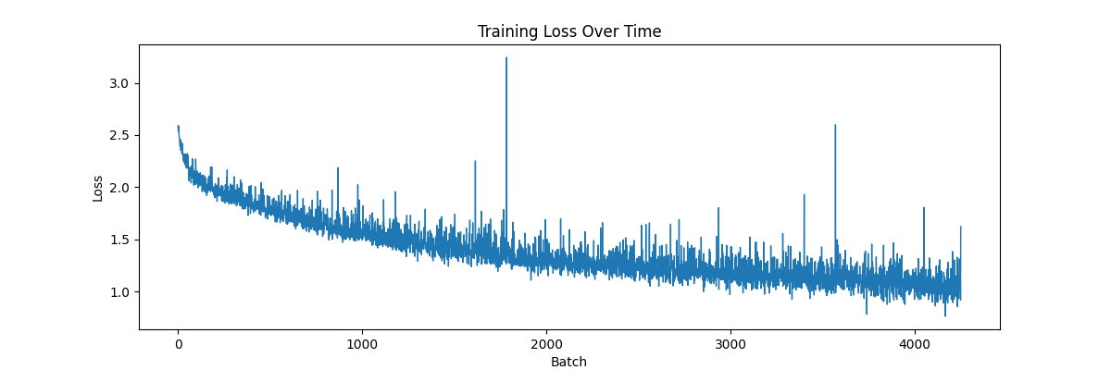
Figure 3: Loss over Epochs
From Figure 3 the model’s loss has a smooth descent over the period of training with some erratic outliers. The combination of both dice loss and binary cross-entropy leaves us with a higher than average loss score and both metrics were affected by the model’s pos_weight and neg_weight hyperparameters. These parameters influenced the model's reaction towards false negative (missed houses) and false positive (incorrectly predicted houses) predictions.

Epoch | Acc | IoU | Loss | Dice
1 | 0.864 | 0.145 | 2.037 | 0.233
10 | 0.929 | 0.267 | 1.442 | 0.388
20 | 0.935 | 0.295 | 1.295 | 0.421
30 | 0.942 | 0.335 | 1.187 | 0.477
40 | 0.946 | 0.382 | 1.114 | 0.517
50 | 0.951 | 0.446 | 1.009 | 0.583

Table 1: Results of Training for 50 Epochs
As seen with our data above we notice a slow increase in all metrics showing the model to slowly improve, however over large periods. As we previously mentioned we passed several hyper parameters during training including learning rate, batch size, and patience. To achieve the results we have shown we used a learning rate of 0.0001, batch size of 8, pos_weight of 6, neg_weight of 2, and patience of 10.
Among our quantitative results we had the model also save qualitative results too. Namely we had the model also save sample predictions and had them masked over the image as shown in Figures 4 and 5.

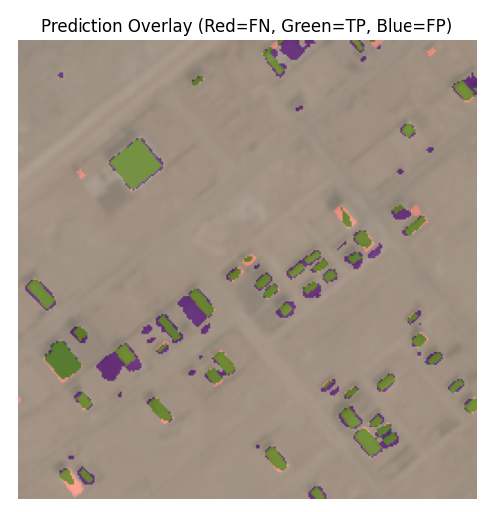
Figure 4: Sample Prediction (Few Houses)
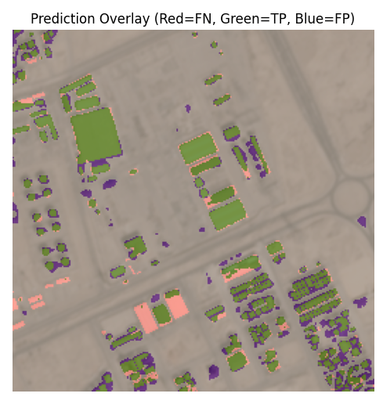
Figure 5: Sample Prediction (Clustered Houses)
Our models appear to be fairly accurate while still falling short on a few houses and areas. From Figures 4 and 5 we can see falsely predicted patches most likely caused by the existence of higher than normal patches of color likely caused by dirt and sand patches. In addition, patches that were surrounded by roads were most likely seen as edges that the model defined as being the borders of a house. Meanwhile the missing houses were most likely caused by not enough edges or features to allow for the model to confidently predict the existence of a house.
- Limitations
The performance of the model reveals several important limitations that constrain its usefulness for precise building-footprint extraction. Although the network performs reliably on large, rectangular structures, it struggles with buildings whose shapes deviate from this pattern. Irregular footprints, curved edges, and non-orthogonal geometries tend to produce incomplete or fragmented predictions. This suggests that the model has learned a strong prior favoring simple, box-like forms and fails to generalize when roof structures become more complex. A related issue appears in scenes where buildings cast strong shadows. The model frequently interprets these shadows as extensions of the building itself or, in some cases, as entirely separate structures. Because shadows can mimic the tonal contrast of rooftops, the network’s reliance on local texture and intensity cues leads to systematic false positives in these regions. Dense urban areas introduce another point of weakness. When buildings are small and tightly packed, the model often merges them into a single mass or fails to identify them individually. The diminished footprint size reduces the number of pixels available to represent unique structures, making separation difficult for a model trained at the chip scale without specialized mechanisms for handling fine spatial detail. Finally, the predicted masks frequently extend beyond the true edges of buildings. Instead of producing tight, boundary-accurate footprints, the model tends to enlarge its predictions, capturing surrounding pavement, vegetation, or rooftop surroundings. This boundary inflation indicates that the model lacks a strong representation of edge-level detail and may be relying too heavily on coarse semantic cues rather than precise geometric structure. These limitations demonstrate that the model captures broad building characteristics but fails to consistently resolve fine-grained spatial distinctions. The shortcomings point toward the need for enhanced training data, additional architectural components, or post-processing strategies if the goal is high-fidelity mapping suitable for detailed planning or cadastral applications.

Beyond the model’s predictive behavior, several practical limitations arise from the structure of the dataset and the computational setup. The SpaceNet-7 scenes are large and numerous, which makes direct training on full-resolution images infeasible under typical GPU memory constraints. Tiling the imagery into smaller chips reduces these demands but introduces its own overhead. The preprocessing required to generate tiles and rasterize building footprints is computationally expensive, and the cumulative cost becomes significant given the size of the dataset. These constraints limit the ability to iterate quickly on experiments or explore more complex model designs.
The characteristics of the imagery also place limits on model performance. The lighting conditions across the dataset are highly uniform, with most scenes collected under similar overhead illumination. This lack of variation restricts the model’s exposure to shadows, oblique lighting, and seasonal differences, which in turn reduces its ability to generalize to more diverse environments. In addition, many scenes share similar landscape patterns, providing relatively limited diversity in building materials, roof shapes, and surrounding context. A model trained under these conditions is less likely to perform well on regions with substantially different architectural or environmental characteristics.
Finally, the spatial resolution of the imagery limits the level of detail available to the model. Small buildings occupy only a few pixels, making their footprints difficult to distinguish from background textures or noise. As a result, even an otherwise well-trained network can fail to detect these structures or may merge them into adjacent features. This resolution constraint forms a structural upper bound on the accuracy that any model can achieve on this dataset, regardless of training strategy or architecture.

- Conclusion
From our work we developed and evaluated a U-Net based deep learning system for building segmentation using the SpaceNet7 dataset that is openly available on GitHub. Our approach to this problem involved preprocessing the raw 4 channels (R, G, B, NIR) satellite tiles and turning them into localized chips and generating their corresponding polygon masks. Then, training on our customized U-Net model, we used a weighted BCE + Dice loss function to optimize.
Through our implementation, we demonstrated that the model is capable of learning meaningful building representations from complex satellite images. The training curves show consistent improvement across epochs, and the model achieves a stable IoU and Dice score during validation. Qualitative visuals further confirm that the model identifies many building structures, particularly in regions with well-defined edges and consistent lighting.
Despite these strengths, our results also bring light to several challenges. The model struggles with very small and irregular structure, dense urban regions, and areas where NIR or RGB signals might be too weak and noisy. In addition, the existence of shadows causes the model to falsely identify them as houses and introduce hurdles during training. These limitations are amplified by the datasets imbalance caused by the pixels only representing a small fraction of each image. The model only occasionally produces false positives in regions containing building-like textures and geometric patterns.
Overall, the project demonstrates that our U-Net, when combined with appropriate weighting strategies and careful preprocessing, provides a strong baseline for satellite building extraction. The results indicate meaningful progress toward automated large-scale mapping and geospatial analysis tasks. There remains room for improvement, including enhancing data augmentation, more advanced loss functions, balanced sampling strategies, and architectural additions such as attention modules or multi-scale feature extractors.
- Future Work
While our model provides strong performance, there are several directions that can be taken to improve generalization, accuracy, and applicability. Increasing the model's capacity could allow for more significant feature extraction and allow for the model to pick up on smaller details better. By expanding and diversifying the dataset we could preprocess and create a larger dataset of chips instead of only taking one tile at a time from each location and chiping it. This would make our data more robust and allow the model to see more details that it most likely missed for evaluation and validation. Improving our loss function could allow for the model to converge better and experimenting with different functions could yield better results. Using different tools to search for optimized hyperparameters could yield better performance as well. Finding an optimal learning rate, batch size, pos and neg weights, etc. could help the models performance. The evaluation of the model could also be improved by applying other metrics like precision recall and F1 scores.
- References
[1] V. Khryashchev, L. Ivanovsky, V. Pavlov, A. Ostrovskaya and A. Rubtsov, "Comparison of Different Convolutional Neural Network Architectures for Satellite Image Segmentation," 2018 23rd Conference of Open Innovations Association (FRUCT), Bologna, Italy, 2018, pp. 172-179, doi: 10.23919/FRUCT.2018.8588071.
keywords: {Erbium;Economic indicators},

[2] R. Sanya and E. Mwebaze, ‘Identifying patterns in urban housing density in developing countries using convolutional networks and satellite imagery’, Heliyon, vol. 6, no. 12, Dec. 2020.
[3] K. R. Varshney et al., ‘Targeting Villages for Rural Development Using Satellite Image Analysis’, Big Data, vol. 3, no. 1, pp. 41–53, Mar. 2015.

